FEDERAL STATE AUTONOMOUS EDUCATIONAL

INSTITUTION OF HIGHER EDUCATION

“NATIONAL RESEARCH UNIVERSITY

HIGHER SCHOOL OF ECONOMICS”

**ANALYTICAL REPORT**

**Authors:**

An Alina

Skobolev Alexander

Smirnova Valeria

Saint Petersburg

2023

**Information about the company, its strategy**

**Field of activity:** Russian retail of household appliances and electronics, online trading platform (banned in 2016).

**Period of functionality:** 1993 - present.

**History of development:**

2000 - the online store www.mvideo.ru was launched;

2004 - establish a new store format "hypermarket";

2007 - opening of the 100th store, the first IPO among the participants;

2010 - opening of the 200th store;

2012 - opening of the first store outside of Moscow;

2013 - opening of the 300th store;

2016 - the M.Mobile project was launched;

2018 - merger of M.Video with Eldorado.

**For now:**

* 1,074 stores
* 279 cities of Russia

M.Video (M.Video-Eldorado Group) includes two brands: M.Video and Eldorado.

**It has 3 controls:**

General Meeting of Shareholders:

* from the Soviets
* from the Audit Commission
* approves the External Auditor

Board of Registration (9 included, 3 revealed):

* forms manifestations of development and offers its execution
* approves the Corporate Society
* required by Internal Audit
* from CEO
* its member is on the Strategic and Digital Transformation Committee
* his board is on the audit committee
* its member is on the Remuneration and Nominations Committee

CEO:

* get operational management

**Activities:**

* Sale of electronics and home appliances
* Maintenance of electronics and home appliances
* Collection and recycling of electronics and household appliances
* Development of mobile technologies in sales
* Market and Consumer Behavior Research

**Strategy:**

The core of the company's Strategy-2022 is the transition from an omnichannel approach to the ONE RETAIL model through the complete digitalization of the customer experience, erasing all boundaries between the retail environment and online and offline sales channels. To reach this goal, the company is tackling the challenge of building a modern, data-driven organization, embedding digital technologies into all of the company's business processes and achieving maximum personalization in customer relationships. MVideo is committed to digitalization at every point of contact with customers and to create an opportunity for each customer to form their own retail ecosystem. The acquisition of Eldorado created an opportunity for the group to form a complete geographic coverage in Russia, gain access to the widest possible audience of customers, as well as to all formats of stores, in all segments - from budget to premium.

**Brief description of the market**

M-video is the market leader in electronic and household appliances in Russia with a 27% share. According to various sources, the entire Russian consumer electronics market is valued at more than $25 billion, with an average annual growth rate of 10% over the past five years. At the same time, in 2020 the market grew stronger - by 22%, due to increased demand from buyers.

**Main competitors:**

1. DNS

Revenue: 562 billion rubles

Profit: 24.9 billion rubles

Stores: over 2,200

Cities: over 1,000

2. Citylink

Revenue: 500 million rubles

Profit: 36.8 billion rubles

Stores: more than 650 pcs.

Cities: more than 360

3. Svyaznoi

Revenue: 15 million rubles

Profit: 101 billion rubles

Stores: more than 2600 pcs.

Cities: more than 1100

**Analysis of the balance sheet structure, the structure of the profit and loss statement**

The information about financial analysis was taken from the official website ([https://www.mvideoeldorado.ru](https://www.mvideoeldorado.ru/fileadmin/user_upload/ifrs_reporting/ru/2021/M_video_IFRS_Cons_FS_21-r_.pdf)) and converted into excel and translated into English (attached in LMS). The screenshots of the balance sheet of the past three years are below.

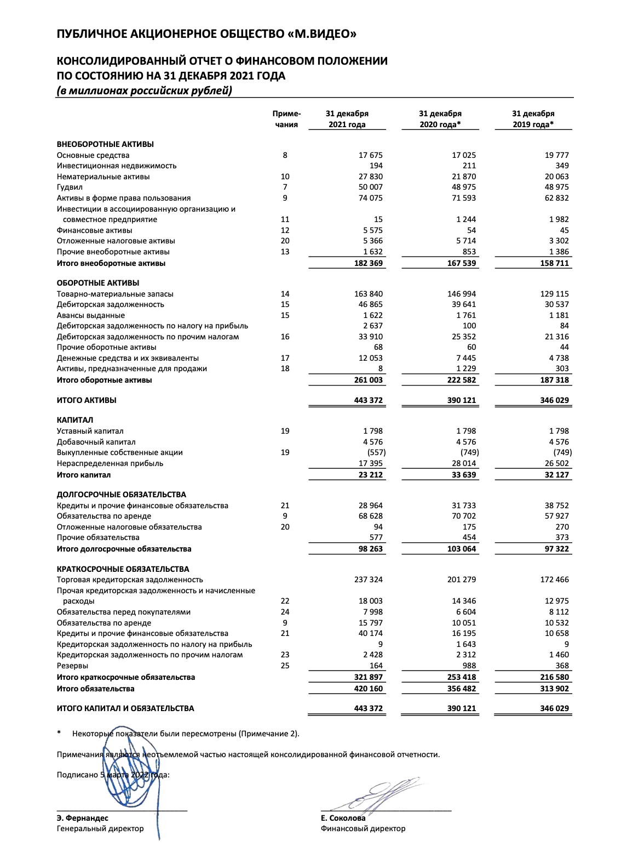

**Vertical analysis**

The essence of this method is that we calculate the share of concrete assets and liabilities in its total sum. It provides us with the information about assets and liabilities structure and income and loss structure.

The vertical analysis of the balance sheet of the investigated company indicated that the fixed assets prevailed in current assets - their share was about 34% in 2017. The share of intangible assets was the same 34% in that year. The next largest asset was deferred tax assets with the share of 18%, then it was ​​financial assets reached the amount of 10%. The lowest part of the asset belongs to the other non-current assets and reached 4%.

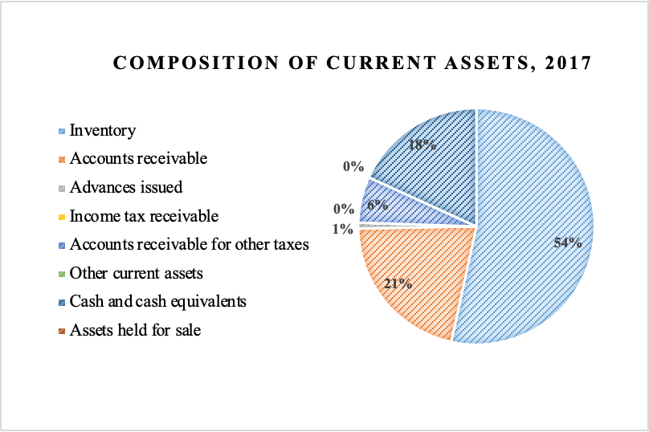

Regarding current assets, inventory took the largest part - about 53% in 2017. The second largest figure was accounts receivable reaching 21%, then cash and cash equivalents with the share of 18%. Accounts receivable for other taxes was the 4th largest figure, its value was 6%. The last significant indicator was advances issued with the share of 1% only.

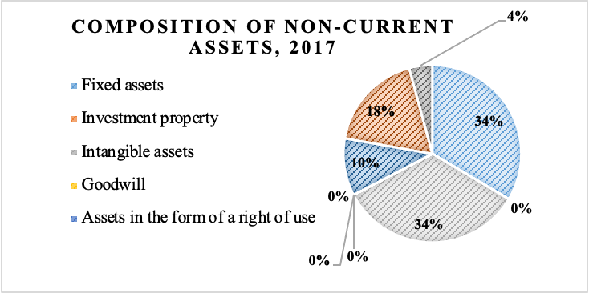

In long-term liabilities reserves were the only significant indicator and took the whole 100%.

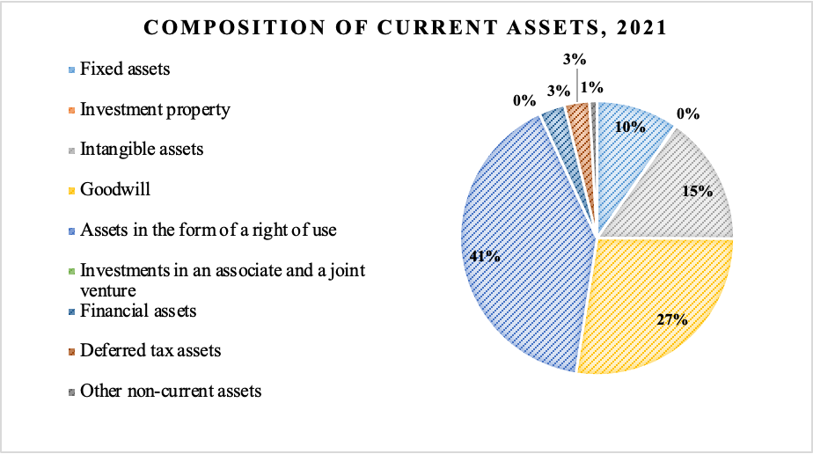

In short-term liabilities trade payables were the key figure and took 79%. The second significant index was other accounts payable and accrued expenses with the value of 9%, obligations to customers having the same value of 9%. Accounts payable for other taxes took 2%. Accounts payable on income tax and loans and other financial liabilities took 1%.

The vertical analysis of the profit and loss statement showed that cost of sales reached 77%, commercial, general and administrative expenses had the value of 21%, operating profit was about 4%, profit before income tax had the same value of 4%. Both other operating income and income tax expenses were 1%.

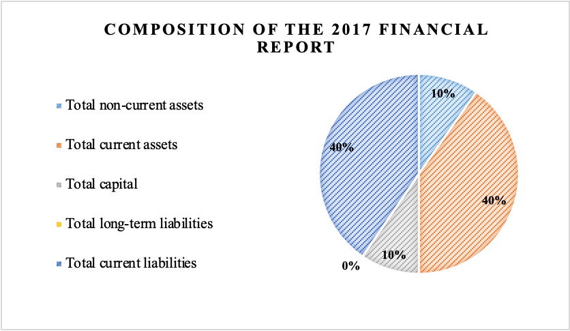

Composition of the financial report in 2017 had the following structure: total non-current assets - 10%, total current assets - 40%, total short-term liabilities - 40%, total capital - 10%, total long-term liabilities - 0, 002%.

The composition of the financial report in 2021 has the structure presented in the following pie charts. The changes are particularly described in the vertical analysis.

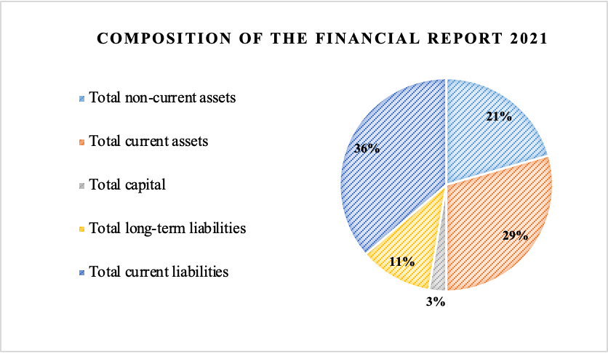

**Horizontal analysis.**

The essence of this method is to compare the same indicators within the studied period. In this section the changes in assets and liabilities within the past 5 years will be shown on the graph and particularly described.

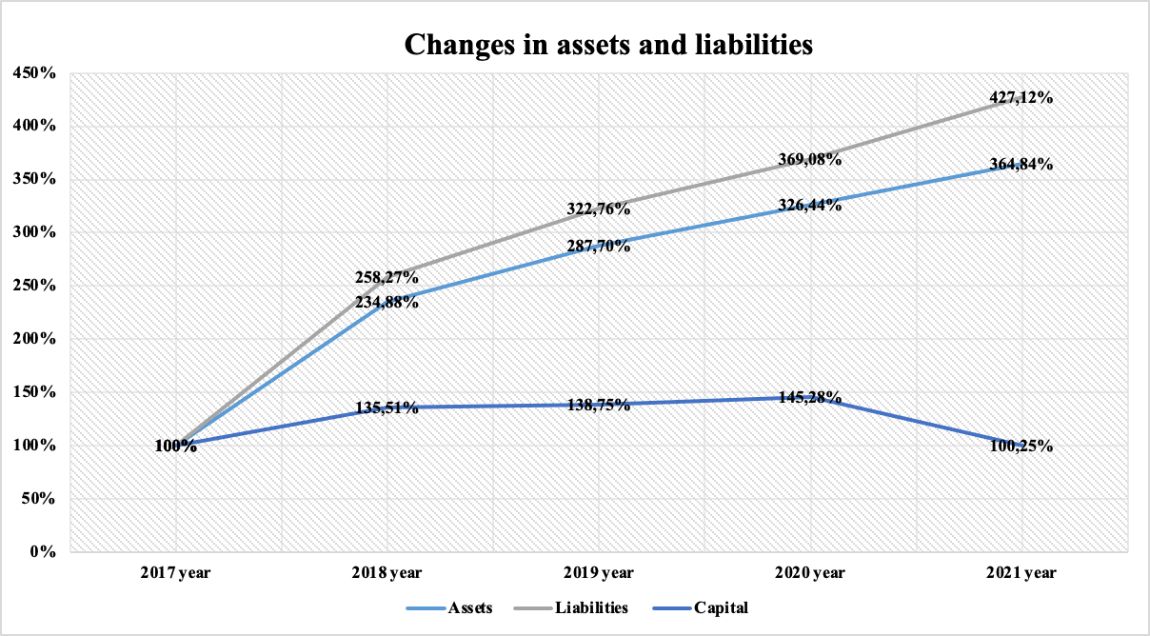

The share of intangible assets doubled up to 70% in 2018, but in 2019 the structure of assets changed. Since then the assets in the form of a right of use has started to predominate. Its share reached 40% in 2019, 43% in 2020 and 41% in 2021. In 2019 the share of goodwill also sharply decreased from 0% to 31% and remained almost at the same level decreasing insignificantly to 27%.

Regarding current assets, here the share of inventory prevailed during the whole investigating period and reached 86% by 2021 starting from 53% in 2018. The second share is accounts receivable, its share was between 16 to 25% for the whole period. The third largest indicator is cash and cash equivalents that sharply decreased during the investigated period starting from the value of 18% in 2017 and 14% in 2018 and declining to 2% in 2019, then reaching 4% in 2020 and 6% in 2021. Accounts receivable for other taxes showed stable increase within the past 5 years, rising from 6% in 2017 to 9% in 2018 then reaching the value of 11% in 2019 and 13% in 2020, finally, getting the point of 18% in 2021.

Composition of the financial report within the past 5 years has changed significantly. The share of current assets decreased from 40% in 2017 to 29% in 2021, the share of non-current assets doubled and reached the point of 21% in 2021, the share of short-term liabilities slightly decreased from 40% to 36%, the share of capital declined significantly from 10% to 3%, the long-term liabilities vice versa increased from 0,002% to 10%.

The revenue, cost and gross profit have also risen significantly. But if revenue and cost of sales rose steadily, the index of gross profit rose only till 2020 and then slightly declined to 2021.

The horizontal analysis also showed a significant profit decline. First, the operating profit rose to 2019 and started to decrease after this year and declined significantly after 2020. Gross profit rose up to 2020 and started to decrease insignificantly after this year. Profit before income tax and net profit has been developing in the same trajectory.

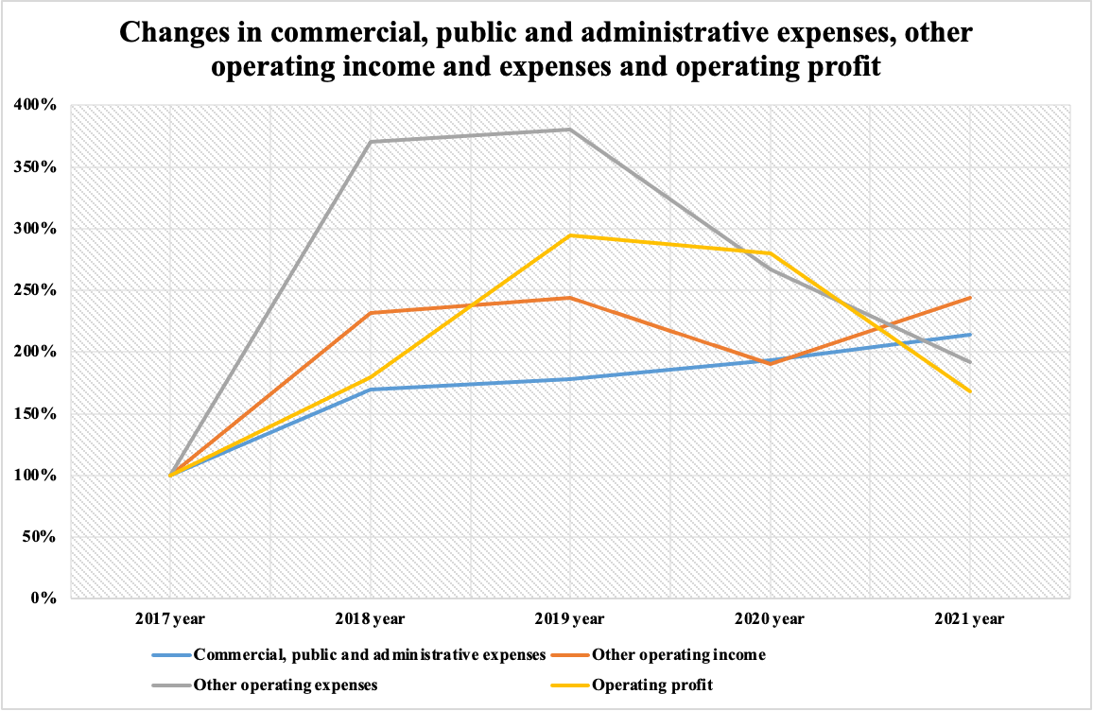

Horizontal analysis of changes in commercial, public and administrative expenses, other operating income and expenses and operating profit reveals that operating expenses rose sharply up to 2018 then continued to grow steadily and then after 2019 suddenly started to slump. At the same time commercial, public and administrative expenses saved the upward trend with a slight decline in growth tempo. Operating profit climbed up to 2019 and then started to decline gradually in 2020. Other operating income saved a moderate upward trend with the exception of drawdown in 2020 that could be connected with COVID-crisis.

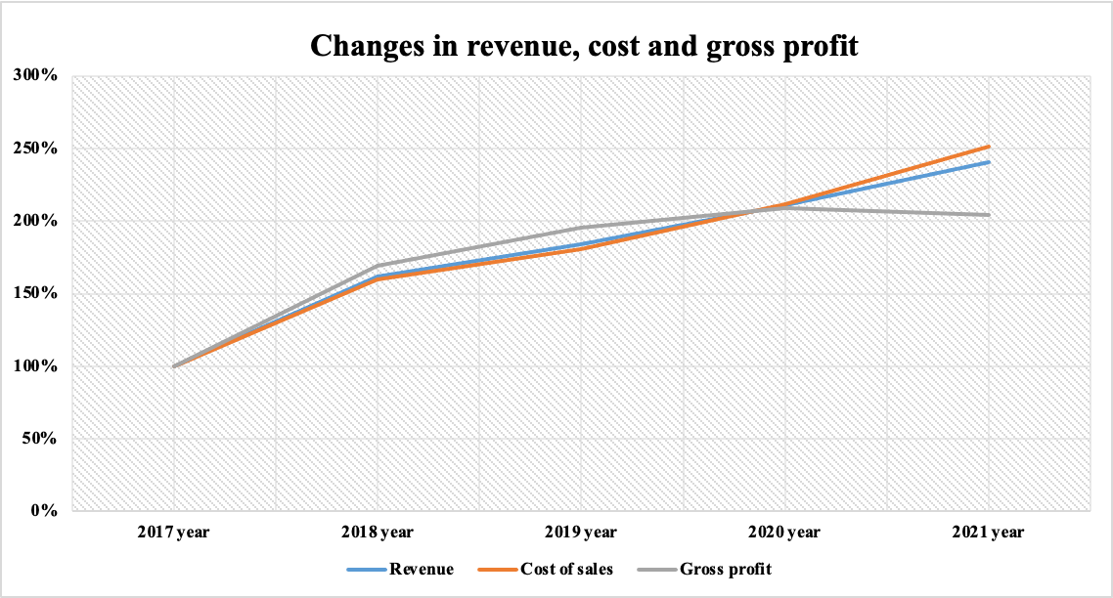

The horizontal analysis of revenue, cost and gross profit indicates a moderate upward trend, however, the gross profit started to plunge after 2020.

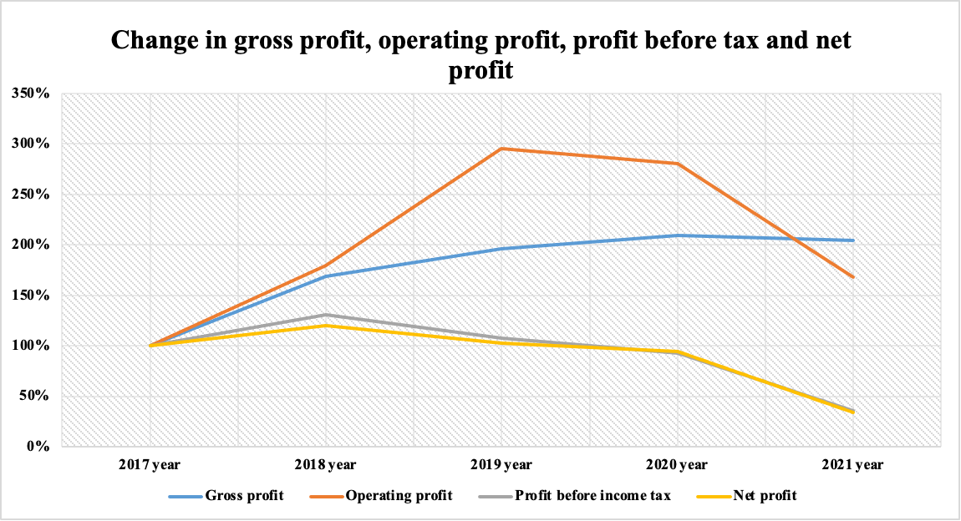

The analysis also provided us with information about profit changes. The operating profit soared up to 2019 and started to decline slowly until next year and in 2020 it plummeted. Gross profit however increased steadily until 2020 and started to decline steadily after 2020. The indicators of net profit and profit before income tax followed the same trend and went down after 2018.

**Ratio analysis:**

For the ratio analysis we took 8 main indicators:

1. Coefficient of autonomy
2. Coefficient of long-term financial independence
3. Coefficient of financial dependence
4. Coefficient of provision with own working capital
5. Capitalization ratio
6. Funding ratio
7. Coefficient of long-term attraction of borrowed funds
8. Coefficient of maneuverability of own capital

**Coefficient of autonomy**

The coefficient of autonomy (CA) shows how the company is independent of creditors. It reflects the share of equity in the composition of all sources of financing. The higher the value of the coefficient, the more likely the company can repay debts at its own expense. Generally accepted normal value: 0.5 or more (optimum 0.6-0.7).

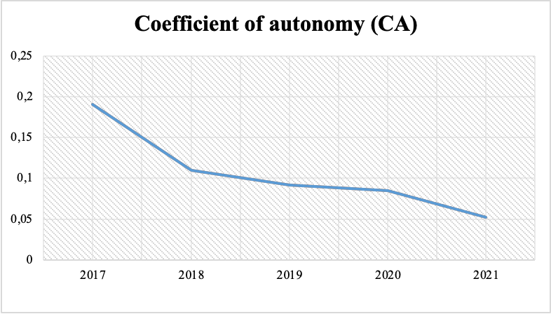

In our example, CA for the analyzed period decreases from 0.19 in 2017 to 0.19. to 0.05 in 2021, which reflects an increase in the company's dependence on external creditors.

**Coefficient of long-term financial independence (LFI)**

The coefficient of long-term financial independence (LFI) shows what part of the total value of the company's assets is formed from the most reliable sources of financing, that is, it does not depend on short-term borrowed funds.

In essence, this is a refined coefficient of autonomy. If the company's liabilities include long-term liabilities, it is advisable to use this coefficient instead of the autonomy coefficient. One of the recommended values of this coefficient is 0.9, the critical value is 0.75.

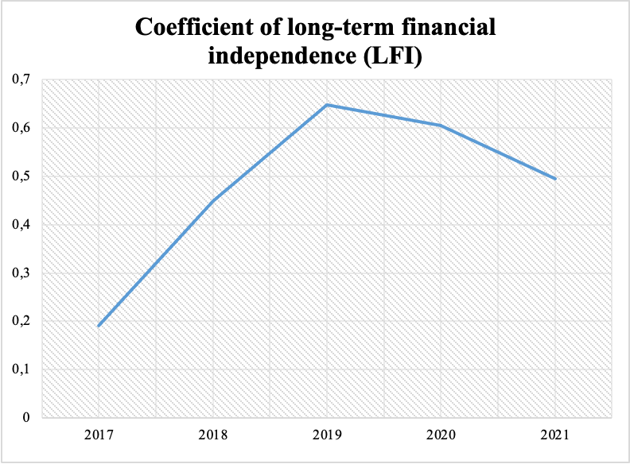

According to the conditions of our example, the CFLF for the analyzed period increases from 0.19 in 2017 to 0.5 in 2021, which reflects a decrease in the company's dependence on short-term borrowings.

**Coefficient of financial dependence (CFD)**

The coefficient of financial dependence (CFD) demonstrates the dependence of the enterprise on external sources of financing.

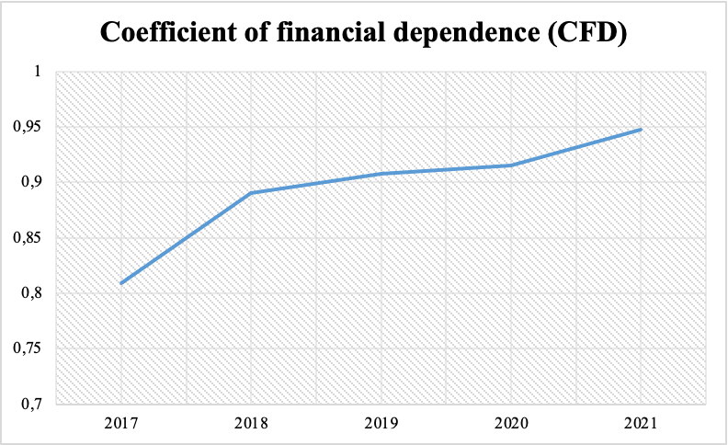

Shows the ability of the enterprise, having liquidated its assets, to fully repay its liabilities. A financial dependency ratio of no more than 0.6–0.7 is considered normal. to 0.95 in 2021, reflecting an increase in the company's dependence on external creditors. The optimal factor is 0.5.

**Coefficient of provision with own working capital (CPOWC)**

The coefficient of provision with own working capital (CPOWC) allows you to calculate the share of own working capital in current assets.

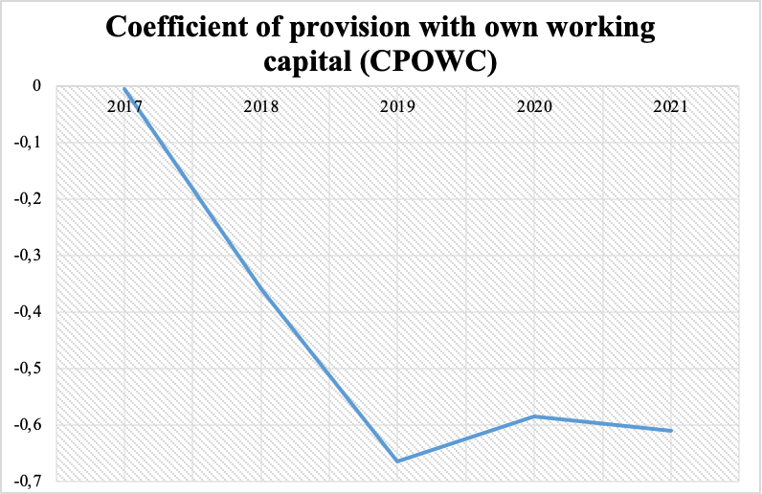

CPOWC determines the degree to which an organization is provided with its own working capital necessary for its financial stability. Normal value: 0.1 or more. In our example, KOSOS for the analyzed period decreases from -0.01 in 2017 to to a negative value of -0.61 in 2021, which characterizes a sharp decrease in own working capital.

**Capitalization ratio (CR)**

Capitalization ratio (CR) - shows the ratio of borrowed and owned funds.

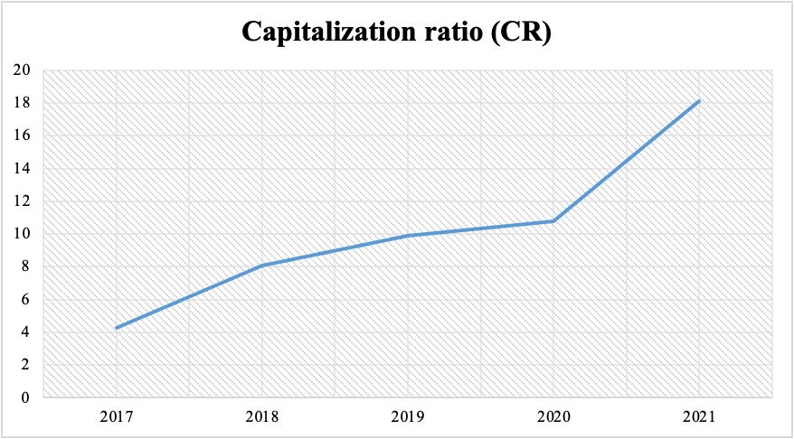

The more the coefficient exceeds 1, the greater the dependence of the enterprise on borrowed funds. In the example, QC for the analyzed period increased from 4.25 in 2017 to to 18.10 in 2021, reflecting a sharp increase in the company's dependence on debt sources of financing.

**Funding ratio (FR)**

Funding ratio (FR) shows which part of the activity is financed by own funds, and which part is financed by borrowed funds.

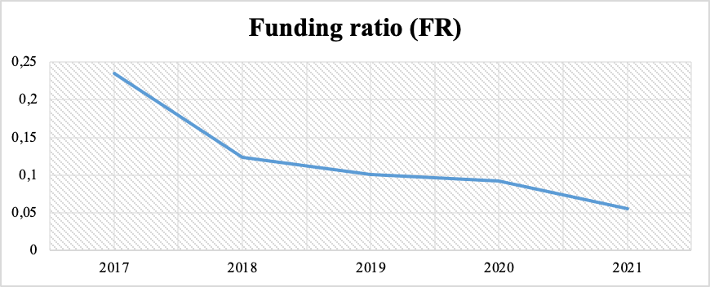

The lower this indicator, the more dependent the company is on borrowed capital. According to the conditions of our example, the CF for the analyzed period decreases from 0.24 in 2017 to 0.24. to 0.06 in 2021, which reflects an increase in the company's dependence on borrowed sources.

**Coefficient of long-term attraction of borrowed funds (KLABF)**

The coefficient of long-term attraction of borrowed funds (KLABF) shows what part of the sources of formation of non-current assets at the reporting date falls on equity, and what part on long-term borrowed funds.

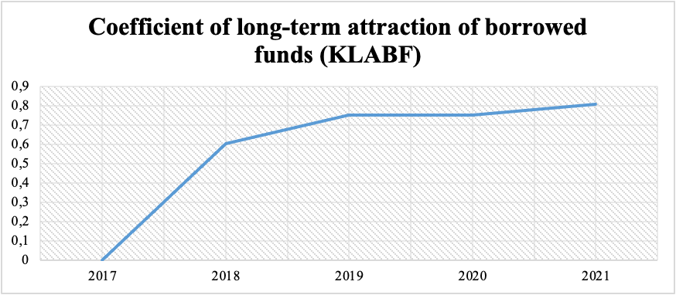

The high value of this indicator indicates a strong dependence on attracted capital, the need to pay in the future significant amounts of money in the form of interest on loans. In the example under consideration, the STSC for the analyzed period increased from zero in 2017. to 0.81 in 2021, showing a leveraged increase in equity capital.

**Coefficient of maneuverability of own capital (CMOC)**

The coefficient of maneuverability of own capital (CMOC) - shows what part of the net working capital accounts for 1 rub. own funds.

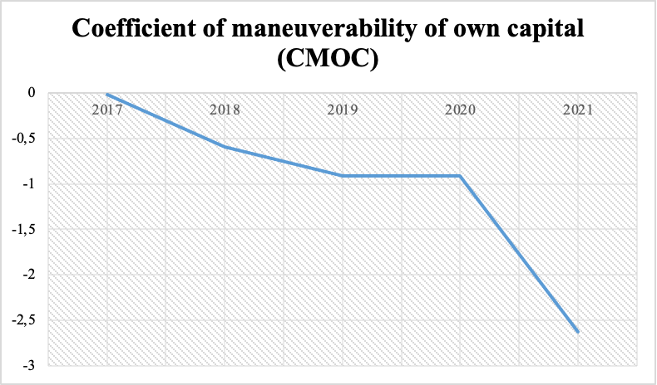

The coefficient of maneuverability characterizes what share of sources of own funds is in a mobile form. The recommended value is 0.5 or higher. According to the conditions of our example, KMSC for the analyzed period decreased from -0.02 in 2017 to to -2.62 in 2021, indicating a decline in capital agility.

**Creditworthiness analysis**

We used the method of analyzing the creditworthiness of the enterprise according to the method of Sberbank of the Russian Federation.

In the process of credit analysis, the liquidity of the company's assets and the liquidity of its balance sheet are calculated. Using a certain set of indicators based on financial statements, we calculate the borrower's creditworthiness.

To assess the fin ancial condition of the borrower, we will use the Sberbank methodology where there are 5 indicators divided into three groups. These indicators and their description will be presented in the table below.

| **Group** | **Indicator** | **Description** | **The limit values** |
| --- | --- | --- | --- |
| Liquidity ratios | The absolute liquidity ratio (K1) | This indicator characterizes the ability of an organization to repay current short-term liabilities with the most liquid assets in full within the established time frame. It is calculated as the ratio of cash and short-term financial investments to short-term liabilities, less deferred income and provisions for future expenses. | 0.2 |
| The intermediate coverage ratio (K2) | financial ratio associated with highly liquid income to short-term liabilities (current liabilities). The data for calculation is the balance sheet of the company | 0.8 |
| The current liquidity ratio (total coverage ratio) (K3) | It is a general indicator of the solvency of an organization. It is calculated as the ratio of current assets to current liabilities less deferred income and provisions for future expenses. | 2 |
| The ratio of own and borrowed funds | The ratio of equity to debt (K4) | This ratio characterizes one of the aspects of the financial stability of the organization and is calculated as the ratio of equity to the sum of long-term liabilities and short-term liabilities less future income and reserves for future expenses. | 1 |
| The coefficient of turnover and profitability | The ratio of turnover and profitability (K5) | Achieving a certain level of profitability indicator (K5) also characterizes the degree of creditworthiness of the borrower and is calculated as the ratio of profit from sales to revenue from the sale of goods. | 0.15 |

For each borrower, each of the indicators in the table is calculated. Further, the calculated indicators are summed up in accordance with their weights. At the last stage, the borrower is assigned a rating or class that determines its creditworthiness.

Below is the division by class:

| **Coefficients** | **1rd class** | **2nd class** | **3rd class** |
| --- | --- | --- | --- |
| К1 | 0,2 and more | 0,1 - 0,2 | less than 0,1 |
| К2 | 0,8 and more | 0,5 - 0,8 | less than 0,5 |
| К3 | 2,0 and more | 1,0 - 2,0 | less than 1,0 |
| К4 | 1,0 and more | 0,7 - 1,0 | less than 0,7 |
| К5 | 0,15 and more | less than 0,15 | unprofitable |

**Calculations:**

|  | **2018** | **2019** | **2020** | **2021** |
| --- | --- | --- | --- | --- |
| Cash Ratio  K1 | 45291 | 45291 | 45291 | 45291 |
| Cash Ratio  K1 | 0,39 | 0,27 | 0,18 | 0,21 |
| Quick Ratio  K2 | 0,46 | 0,35 | 0,27 | 0,30 |
| Current Ratio  K3 | 0,99 | 0,91 | 0,87 | 0,88 |
| Leverage Ratio  K4 | 0,24 | 0,12 | 0,10 | 0,09 |
| Profitability  K5 | 0,04 | 0,05 | 0,07 | 0,05 |

**Results:**

| **Coefficients** | **2018** | **2019** | **2020** | **2021** |
| --- | --- | --- | --- | --- |
| 0,11 | 1 | 1 | 2 | 1 |
| 0,05 | 3 | 3 | 3 | 3 |
| 0,42 | 3 | 3 | 3 | 3 |
| 0,21 | 3 | 3 | 3 | 3 |
| 0,21 | 3 | 3 | 3 | 3 |
| S | 2,78 | 2,78 | 2,89 | 2,78 |
| Class | 3rd CLASS | 3rd CLASS | 3rd CLASS | 3rd CLASS |

We determine the class of borrower as third class, which means that this lending to the enterprise is associated with increased risk.

**Final conclusion**

The vertical and horizontal analysis of composition of both balance sheet and financial reports showed the significant changes in companies assets, debt, and income and losses structure. These changes could have been caused by different reasons. We suppose that the increase of goodwill and decrease of profits, for example, are results of the acquisition of “Eldorado” in 2018, this change is a sign of a company’s market value increase. However it also can cause net profit and profit before income tax loss due to the fact that an acquired company demands resources to integrate into the new structure. That means that this deal certainly added an investment attractiveness to “MVideo”. Besides, drawdowns of operating expenses in 2020 that could be perceived as a response to COVID-crisis. In turn the plunge of other operating income, gross profit can also be a sequence of the crisis.

Creditworthiness analysis showed that the class of borrower was third class, which means that this lending to the enterprise is associated with increased risk.

Despite the fact that Sberbank 's methodology showed disappointing results and gave the third class of creditworthiness , the rest of the analysis shows acceptable results relative to competitors in the industry.